f-stop Releases New Drone Cases
Release: September 15, 2022
Leading camera bag brand, f-stop, launches two new products – Drone Case Large & Drone Case Small.
St. Louis, MO September 15, 2022 – f-stop, the global leader in adventure photography bags, launched the first drone products in company history with the release of the Large Drone Case and Small Drone Case. The cases feature a clam shell design for efficient organization of the drone and accessories. The cases come with padded walls and weatherproof material for superior protection. The cases also come with handles, so they work well standalone and fit into the top compartment of f-stop camera backpacks.
“We developed these cases because after customers and ambassadors kept sending us images of their loaded f-stop bags with drones, along with their camera gear. We reached out to the folks to learn how we could meet their needs, and the product evolved organically with lots of input about needed and desired features, functionality, and design from users in the field. The result is the Drone Cases Small and Large which we are excited to launch today..”
Falk Hicke, f-stop Director of Brand

The cases are available in the f-stop proprietary DuraDiamond® fabric and come in Cypress Green. The cases are available for to purchase at www.fstopgear.com and through select dealers September 15th.

About f-stop
f-stop was founded in 2006 with a vision to combine the best camera bags with the best outdoor performance backpacks, and in the process, revolutionized the way visual storytellers carry their equipment. f-stop continues to focus on innovation by harnessing the insights of their Brand Ambassador team to create industry-leading products.

The DuraDiamond® Large Drone Case - $99.99 / €99.99

User review by Leighton:


Great all-around drone case!

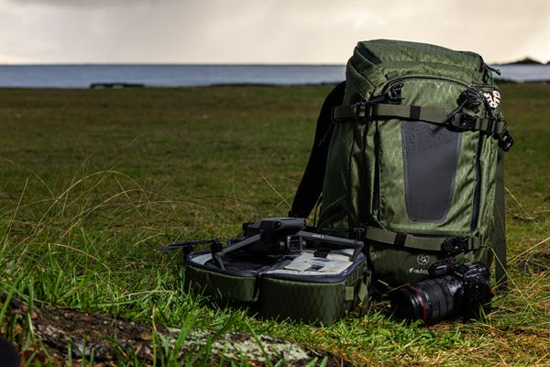
I have had the large drone case, and what I really like about it is everything you need fits in it. I like the memory card holders and the iPad pocket. I have the Mavic 2 and Mavic 3 pro, and there’s enough room in it for extra batteries and the controller, even the charging terminal. It fits nicely into my f-stop DuraDiamond® Tilopa bag along with all my other photo gear. If I only have aerials to shoot, then the case works well as a standalone. The DuraDiamond® material on the exterior of the case is solid, water resistant and holds up in the elements keeping the drone dry and protected. Would highly recommend.

Features of the DuraDiamond® Small Drone Case:

- Large Drone Case compatible with foldable wing drones
- Compatible drones include - DJI Mavic Pro 2, DJI Mavic Air 2, DJI Mavic Mini, DJI Mavic 3, Autel Robotics Evo I ProI, Parrot Anafi, Ruko F11Pro, UranHub, and other similar drones
- Designed to fit into f-stop Mountain Series and Ultra-light camera packs
- Compatible with most hiking backpacks with 20L capacity or greater
- Clam shell design provides two padded sections with adjustable dividers
- Top compartment secured with mesh for visibility and easy access
- Storage room for extra batteries, blades, cables, etc.
- DuraDiamond® Weather resistant fabric
- Padded sides and interior storage for protection
- Carry handle with closure clip so case can be attached to a belt or backpack, etc.
- Padded slot for small tablet - iPad mini or smaller
- Lid includes four pockets with magnetic closures for media cards, cables, etc.

Specifications:

- Weight: 1 lb | 485GR
- External Dimensions: (in): 6.1 Depth x 5.9 x 11 Length
- External Dimensions (cm): 15.5 Depth x 15 Width x 28 Length
- Internal Dimensions: (in): 5.9 Depth x 5.7 x 10.5 Length
- Internal Dimensions: (cm): 14.5 Depth x 14 Width x 17 Length

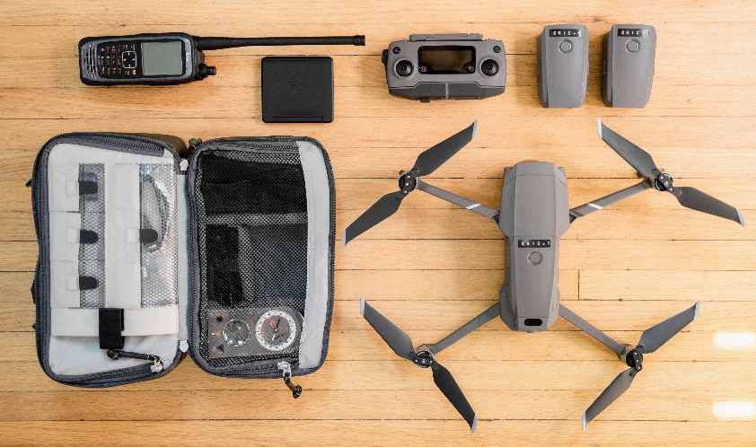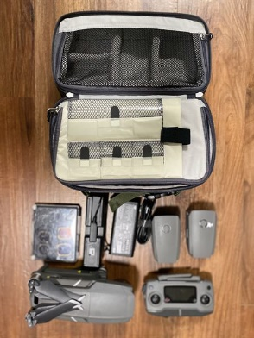

The DuraDiamond® Small Drone Case - $79.99 / €79.99

User review by J:

Best Drone Case I've used.
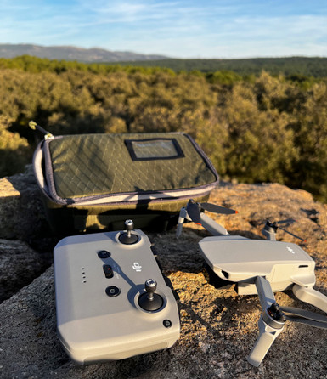
I've been using the DuraDiamond® Drone Case – Small for a while, and it is the only drone case I use now. I found the original OEM case slightly cumbersome and not very easy to carry inside my current photography bag, so the f-stop Small Drone case was a very welcome addition to my kit. It fits great in my current camera bag, but also works great as a standalone case too, with the carry handle, or with a strap through the external loops. I use this with my DJI Mini 2 and can store all the components, Drone, Remote, Charger pack, spare props, and SD cards, with a pocket for an iPad Mini and space for my filter pack too.

Features of the DuraDiamond® Small Drone Case:

- Small Drone Case compatible with foldable wing drones
- Compatible drones include - DJI Mavic Pro 2, DJI Mavic Air 2, DJI Mavic Mini, DJI Mavic 3, Autel Robotics Evo I ProI, Parrot Anafi, Ruko F11Pro, UranHub, and other similar foldable wing drones
- Small compact size fits into f-stop Mountain Series and Ultra-light camera packs
- Compatible with most hiking backpacks with 20L capacity or greater
- DuraDiamond® Weather resistant fabric
- Padded sides and interior storage for protection
- Carry handle with closure clip so case can be attached to a belt or backpack, etc.
- One padded internal compartment with adjustable dividers
- Padded slot for tablet
- Lid includes four pockets with magnetic closures for media cards, cables, etc.

Specifications:

- Weight: 9oz | 255GR
- External Dimensions: (in): 3.5 Depth x 6.7 x 9.8 Length
- External Dimensions (cm): 8 Depth x 17 Width x 25 Length
- Internal Dimensions: (in): 3.3 Depth x 6.5 x 9.5 Length
- Internal Dimensions: (cm): 7.6 Depth x 16.5 Width x 24 Length

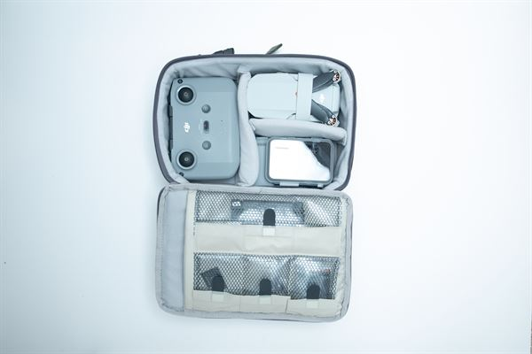
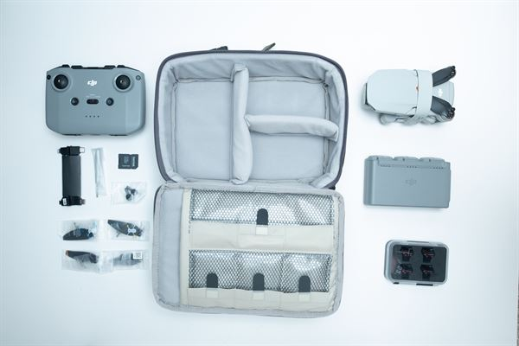
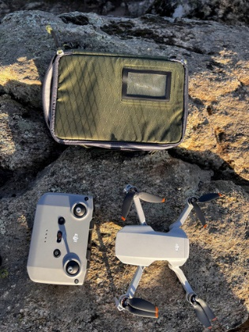

For questions or queries, please reach out to:

Chris Osborn
Director of Marketing | f-stop
chris@fstogear.com
Phone: 314-566-9855

